OMS AVID  OMS AVID Students will:  Become proficient in taking notes in all classes, organization, time-management, study skills, writing, questioning, working with others, reading, and public speaking  Receive access to rigorous courses with support from peer, high school, and college student tutors  Participate in guest speaker forums, leadership activities, college experiences, and field trips such as High School visits, College tours, and visiting college and career centers  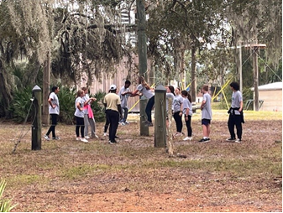  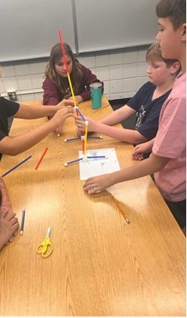 |  | Choose from over 20 different Targeted Learning Themes!  All about Plants/Gardening  AVID  Board games  Colorguard  Crochet  Fantasy Sports  General Enrichment/Study Hall  Jazz and Orchestra  Minecraft  Outdoor and Team Sports  PBIS School Store  Photography  Robotics/STEAM  TV Production  Yearbook  …and more! | Osceola Middle School  - 9301 98th St. N.  - Seminole, FL 33777  - 727-547-7689  - Derrik Craun, Principal  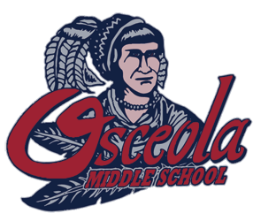  - A School with Fundamental Principles  D

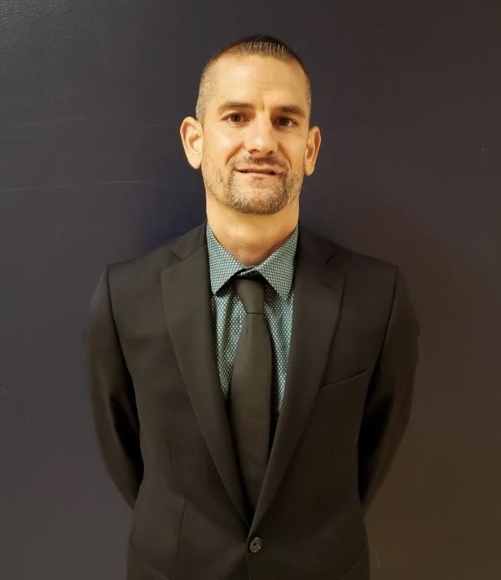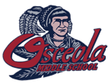  Hello, I am Derrik Craun, the proud principal of Osceola Middle School, and we cannot wait to have you as an OMS Chief! What does it mean to be a Chief?  First of all, OMS Chiefs are engaged. Osceola Middle School is a place where every student will discover an excitement and passion for learning. Whether it be engaging in one of 10 different before and after school clubs, taking part in our school wide STEAM Academy, participating in one or more of our 5 different boys and girls sport teams, or participating on one of our fine and performing arts programs, here at OMS, there is something for everyone. In addition, all OMS students experience a 30 minute daily enrichment period where they choose from over 45 different topics such as Minecraft, Crime Scene Investigation, Crocheting, Fantasy Sports, Outdoor Sports, Robotics, Gardening, various arts and more.  Highest student achievement is a non-negotiable here at Osceola Middle School. In order to help students take ownership in their own learning, OMS Chiefs are organized. Every OMS student manages a school wide binder to support all the work and thinking done each and every day in all 6 of their academic classes. Students have the opportunity to complete their 3 years at Osceola Middle School by earning up to 9 total high school credits if they choose. We also provide the opportunity for students as early as 6th grade to earn career certifications. This past school year, 584 certifications were earned by OMS students.  Finally, OMS Chiefs are connected. Here at OMS, we continuously host events throughout the year to create a culture of connectedness. We begin the middle school experience for perspective families by offering several different guided tour opportunities, orientations, and family events such as Family Movie nights, Fall and Spring Festivals, and student activities like our Peer Connect and Chief Community days in order provide several opportunities for students to experience OMS before their first day of school. | The Chief Way  Guidelines for Success:  Be Respectful  Be Responsible  Be an Active Learner  6th Grade Transition  As we know, the transition from elementary to 6th grade can often seem stressful. At OMS the transition is smooth as we offer several opportunities for students and families to learn about and explore our campus prior to the 1st day of school. In addition, we are lucky to have a Teaming model for 6th grade consisting of 3 teams of core content teachers who share common students. This allows all students to have a school within a school experience with classrooms close in the same hallway and the ability to feel supported and receive common classroom expectations from their teachers.  As you can see, our students will discover a passion for learning and experience a terrific middle school experience. We look forward to having you join the Chief Community where we have something for everyone. For more information, please visit our school website at www.pcsb.org/osceola-ms or find us on Social Media or call 727-547-7689 and we will help you become a Chief today!  Not zoned for Osceola Middle? No problem! Apply for a Special Attendance Request (SAR)  https://www.pcsb.org/sar | OMS Clubs and Programs  OMS Steam Academy for all grades  National Junior Honor Society  Fishing Club  Journalism  Robotics  Mural Club  Leadership Club  Unclub  Athletics  Cross Country  Volleyball  Cheerleading  Basketball  Track  Flag Football  OMS Pep Rallies every 9 weeks!  